## Mengzhou Yao

## 08/21/2020

## IT FDN 110 A

## Assignment07

**Pickling and Structured error handling Script**

**Introduction**

In this assignment 07, the scripts will show how Pickling and Structured error handling work.

**NameError Script**

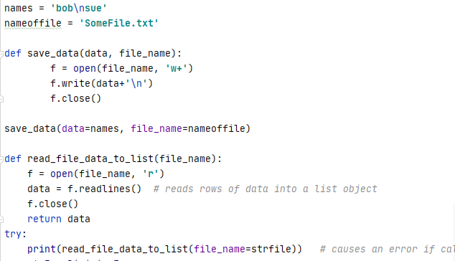

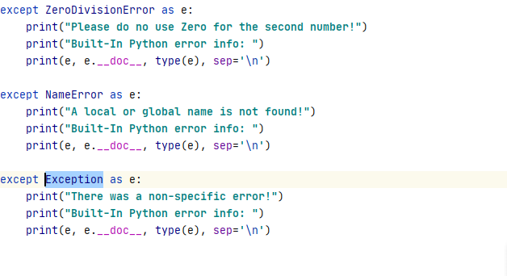

*Figure 1: the screenshot of NameError Script in the PyCharm program*

In Structured error handling function, I write “print(read_file_data_to_list(file_name=strfile

(file_name=strfile)) under “try”; and write three exceptions: ZeroDivisionError

, NameError, Exception. “strfile” is the wrong name and causing the error. The script will display the exception and run its error message. ZeroDivisionError is not the corrected exception and NameError is the correct exception and run its error message.

**The Answer of NameError Script**

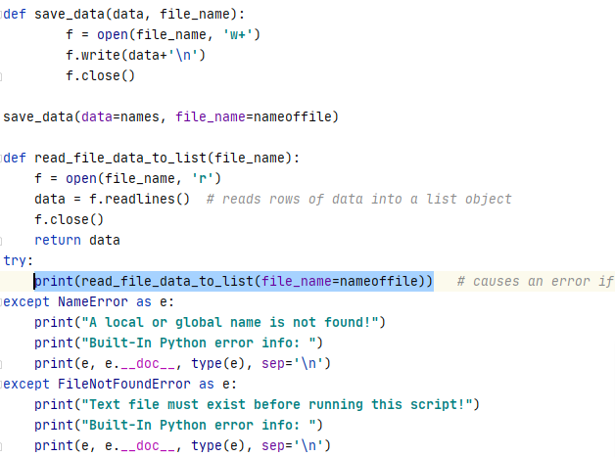

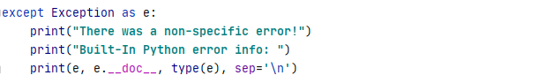

*Figure 2: the screenshot of Answer of NameError Script in the PyCharm program*

Verifying data in the txt.file

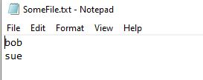

*Figure 3: the screenshot of verifying data in the txt file*

**Zerodivisionerror Script**

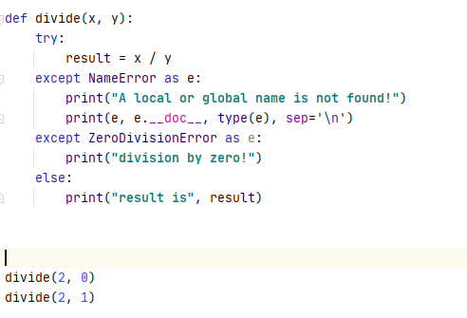

*Figure 4: the screenshot of zerodivisionerror Script in the PyCharm program*

In Structured error handling function, I write “result = x/y under “try”; and write three exceptions: NameError, ZeroDivisionError. I run the function with zero; this is causing the ZeroDivisionError and run its error message. If I run the function without zero, the script display the result with no exception.

*Figure 5: the screenshot of result of zerodivisionerror Script in the PyCharm program*

**Pickle dump and pickle load 1 script**

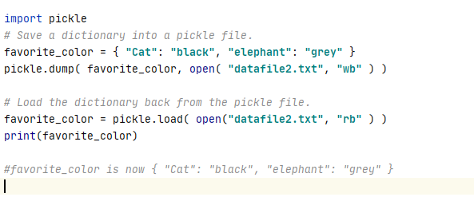 `

*Figure 8: the screenshot of Pickle dump and pickle load script1 in the PyCharm program*

For the above script, I use pickle.dump(data, txt.file) to save data to a pickle file and use pickle.load(data, txt.file) to load data.



*Figure 9: the screenshot of result of Pickle dump and pickle load Script1 in the PyCharm program*

**Pickle dump and pickle load 2 script**

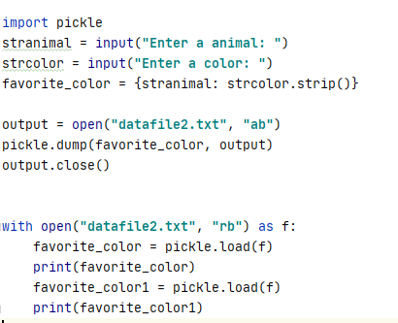

*Figure 10: the screenshot of Pickle dump and pickle load script2 in the PyCharm program*

For the above script, I use pickle.dump(data, txt.file) to append user input data to a pickle file and use pickle.load(data, txt.file) to load all data from txt.file.

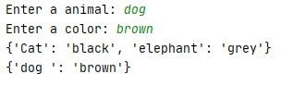

*Figure 11: the screenshot of the result of Pickle dump and pickle load script2 in the PyCharm program*

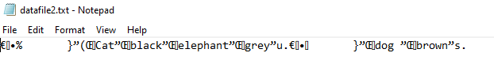

*Figure 12: the screenshot of verifying data in the txt file*

Saving the script

I create a folder in C:\_PythonClass called “Assignment07” and save my script in the folder.

**Summary**

Studying online and using the module 07 video, notes, textbook, , I was able to create four scripts to demonstrate Pickling and Structured error handling Script work.